# Cashier Application (POS System) for CRISTY’S LOVE BURGER HUB

Aryan Jung Karki, Asmit Gahatraj B.K., Rishav Kumar Shah, Shadip Kumar Joshi

B.Sc. (Hons.) Computing, Softwarica College of IT and E-commerce, Coventry University

ST4008CEM: Computing Activity Led Learning Project 1

Giriraj Rawat

July 28, 2022

# Table of Contents

Cashier Application (POS System) for CRISTY’S LOVE BURGER HUB 6

Introduction 6

Aim 9

Objectives 9

Problem Statement 10

Features 11

Functional Requirements 13

Non-Functional Requirements 14

Scope 15

Development Methodology 17

Methodology 17

Tools and Technologies 20

Conceptual Diagram 22

System Architecture 23

Project Plan 24

Prototypes 25

Developed System 30

Login UI 30

Registration UI 32

Product Details UI 35

Update/Delete UI 37

POS UI 39

System Testing 41

Version Control 47

Conclusion 48

References 49

# Table of Figures

Figure 1 6

Figure 2 7

Figure 3 10

Figure 4 12

Figure 5 16

Figure 6 17

Figure 7 19

Figure 8 21

Figure 9 22

Figure 10 23

Figure 11 24

Figure 12 25

Figure 13 26

Figure 14 26

Figure 15 27

Figure 16 27

Figure 17 28

Figure 18 28

Figure 19 29

Figure 20 29

Figure 21 31

Figure 22 31

Figure 23 32

Figure 24 33

Figure 25 33

Figure 26 34

Figure 27 35

Figure 28 36

Figure 29 37

Figure 30 38

Figure 31 38

Figure 32 39

Figure 33 40

Figure 34 41

Figure 35 42

Figure 36 42

Figure 37 43

Figure 38 44

Figure 39 44

Figure 40 45

Figure 41 45

Figure 42 46

Figure 43 47

# Cashier Application (POS System) for CRISTY’S LOVE BURGER HUB

# Introduction

CRISTY’S LOVE BURGER HUB is a fast-food restaurant specializing in burgers for patrons. A *Point of Sale* (POS) is developed for this restaurant. Although this POS is mainly focused for counter desktop in the restaurant, it works on mobile devices connected to the server by internet too. Example of POS is shown in figure 1.

### Figure 1

POS Software (Restora, 2022).

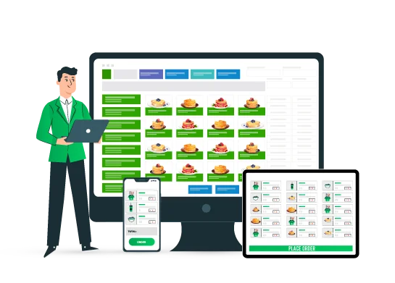

This application streamlines order and transaction process between cashier and customers. Its prioritisation is swiftness, simplicity, and efficiency in order-taking. It, unlike other available applications in market, is PIN protected and can only be accessed first by the manager and then subsequently by the assigned cashier. This double authentication ensures null mishandling of system itself and restaurant assets (viz. counter-cash embezzlement). A successful login provides a user friendly and an ordered interface for order-input along with order status, product details and delivery options (Brophy, 2021).

“One order management system, one database, one inventory. Without these you will never seem seamless to your customer.” — Andy Laudato, COO of The Vitamin Shoppe (Harper, 2021).

### Figure 2

Operation in POS (Miller, 2022).

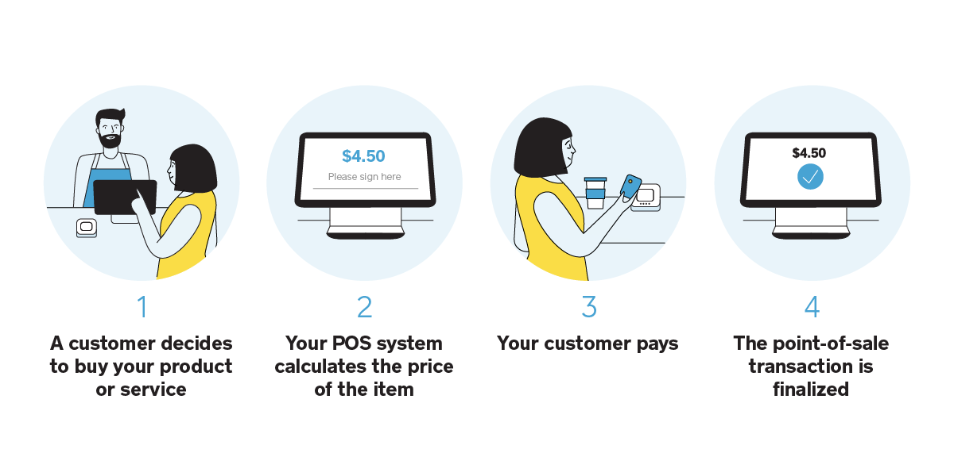

Figure 2 explains operation process of POS.

This system functions under *Create-Read-Update-Delete* (CRUD) application. The database stores restaurant staff’s credentials for login authentication, product details for customer’s query, and order details for delivery purpose and record. The recorded data is retrievable and mutable.

# Aim

Aim of this application is to take customer’s orders efficiently in a systematic manner for quick production in kitchen and swift delivery to consumers.

# Objectives

* Ensures security of staff account and restaurant-assets.
* User-friendly interface facilitates easy operation.
* Login protocol secures dashboard.
* Analyses sales by salesperson or product.
* Inputs via touchscreen, mouse, or keyboard.
* Track sales, taxes, employee performance and customer frequency.
* Automating accounting (Prajapati, 2020).
* Create better and less hectic working environment.
* Mitigate errors.
* Better customer service.
* Replaces traditional pen-paper order-taking method.
* Operation of POS in mobile devices for table-orders (Pos, 2022).

# Problem Statement

Traditional system of noting customer’s order in restaurant with pen-paper is not on par with current technologically developing time. Data organisation and storage are a hassle. Payment of the order can take several steps and many transactions are inconsistent due to mishandling of cash. Since taking orders manually takes a lot of time, kitchen staff starts production late and hence guests are serviced late too. Therefore, there is sever lack of coordination among staff-members. Many guests thereby are forced to wait longer for their turn.

This project solves the aforementioned problems by computerizing order process, which informs kitchen personnel instantly, thus saving time in both order-input as well as production and warrants quick food-delivery. The mandatory login of manager and then of cashier handles misuse of company assets. Easy-to-use UI enables hassle-free and correct orders input. Integrated database also secures history of orders and up-to-date details of staffs and products. Thereby, the system calculates transactions correctly, payment is instant (as shown in figures 3) and guarantee lesser to no mistakes (POSportal, 2020).

### Figure 3

Problems vs Solutions in POS

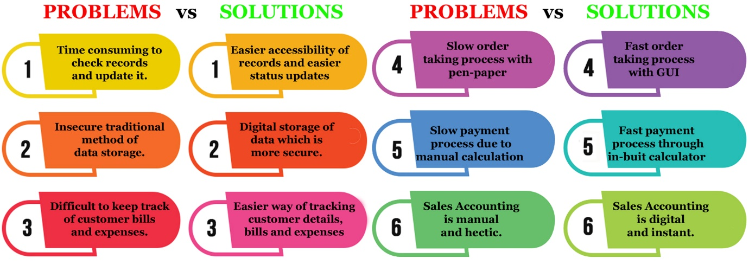

# Features

* Create and manage staff(s) profile
* Registration of employee only under superior’s validation
* Deletion of employee profile only by superior
* Supports multiple user accounts
* Staff login under manager’s permission
* Two-factor staff login verification
* Privacy of staff details
* Simple and user-friendly UI
* Allows multiple order without any calculation mistakes
* Observable order status
* Easy order modification
* Swiftness in order, billing, and transactions
* Swiftness in production and delivery (Pos, 2022).
* Takeaway and dine-in options (Nicasio, 2018).

Figure 4 presents 12 key features of a great POS system.

### 

### Figure 4

Features of POS (Chalberg, 2018).

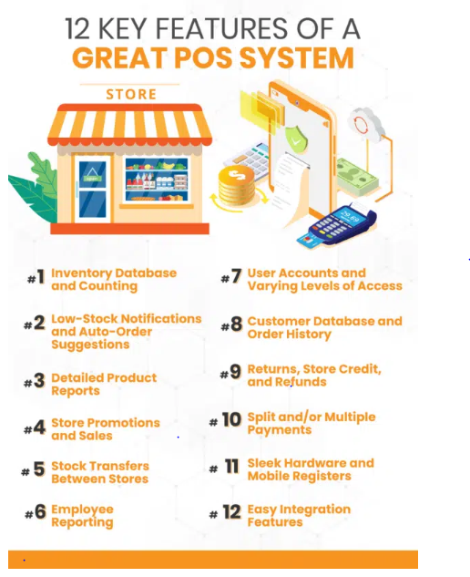

# Functional Requirements

Functional requirements that define what a software must do, what its features and functions are, as follows:

* Two-layer login verification
* Addition and modification of staff database
* Addition and modification of product database
* Delete data in database by only superior
* Categorize products
* Possibility of multiple orders
* Takeaway and eat-in option
* Live update of order status
* Digital calculation and billing (Morisio, 2013)**.**

# Non-Functional Requirements

Non-functional requirements that explain how the system should perform are as follows:

* **Usability:** Easy to use and self-explanatory GUI.
* **Security:** Login with correct pin and Logout after command. Staffs are permitted to check only their credentials.
* **Performance:** Transition among UIs should be within 10 second. Button should return results with maximum lag of 5 seconds. Accounting should not take more than 5 seconds.
* **Changeability of data:** Modification in database should be quick.
* **Capacity:** Stable performance for concurrent 200 orders.
* **Scalability:** Upgradable system.
* **Portability:** Operation in different Operating systemsand mobile devices as *Table POS*.
* **Compatibility:** System requirement is not high.
* **Connectivity:** Connection to monitor in kitchen (Morisio, 2013)**.**

# Scope

Scope is defined collectively by all the preceding topics of aim, objectives, problem statements, features, functional requirements, and non-functional requirements. Figure 5 displays scope of POS system. The main scope of this program is digitisation of employee details, product details and accounting ensuring

* better management of restaurant resources
* employee registration by superior staff
* simplicity in creating, retrieving, editing, updating, and deleting data
* quick and easy order by touch or click on UI
* swiftness in calculation of transaction
* instant order-notification to kitchen
* faster workflow
* better customer service with less queue time for order and delivery
* more sales implying more earnings
* proper utilisation of workforce meaning more work done by limited staff compared to addition of more staff needed for the same amount of work in same timeframe while using traditional ordering method
* instant recording of sales compared to need of extra time and personnel for the same purpose in traditional method

### Figure 5

Scope of POS (Talech, 2020).

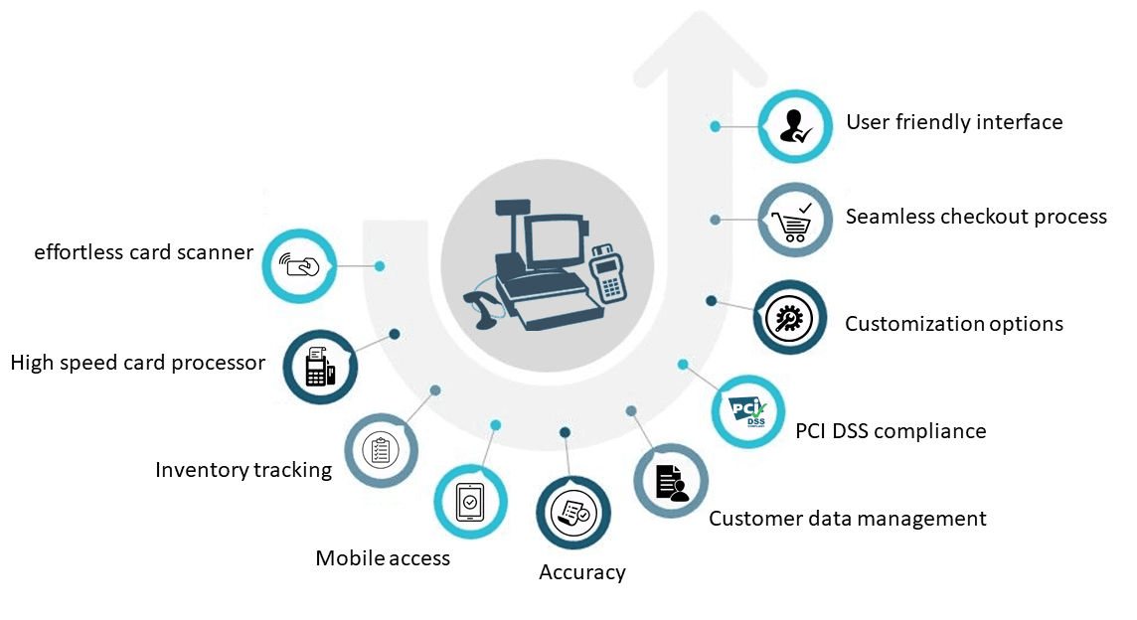

# Development Methodology

Development methodology refers to *Software Development Life Cycle* (SDLC) which provides steps to develop a software from scratch.

## Methodology

*Modern Waterfall Model*, also known as *Iterative Model*, is utilized for development of this software. It is used because of its step-by-step and simple to follow phases for novices in IT field. This method is suitable for virgin developers like us who just embarked on the field of *‘Software Engineering’*. Figure 6 presents all stages in this model.

### Figure 6

Phases in Modern Waterfall (GeeksforGeeks, 2021).

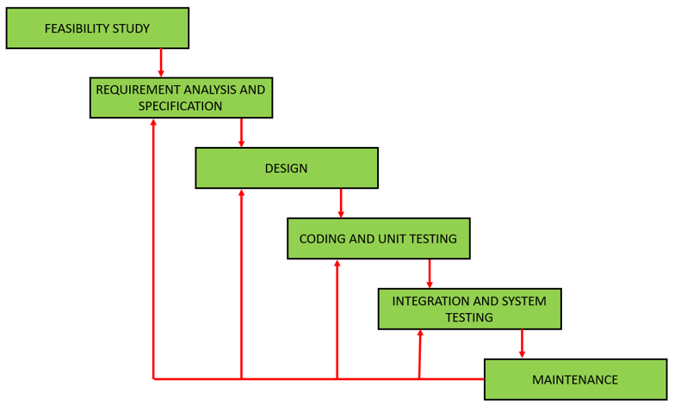

At first, a ‘Feasibility study’ was conducted by the developing team of the practicability of this software through discussions and research. After that followed ‘Requirement Analysis and Specification’ phase, which involved ‘Requirements Gathering and Analysis’, and ‘Requirement Specification’ creating a *Software Requirement Specification* (SRS) document, which documented functional and non-functional requirements, aim, objectives, features, problem statements, scopes, and details of software. Subsequently, a structured ‘Design’ was finalized iteratively through object-oriented approach considering various objects in problem domain and solution domain along with their relationships. Then, design was translated into source code using Python programming language in ‘Development’ phase to build a working software, which was unit tested and integrated incrementally in the following ‘Integration and System-testing’. The software was then ready to be released to users and regularly maintained in the final ‘Deployment and Maintenance’ stage (Nitika, 2018). Above phases were revisited as per need due to new user-requirements and feedbacks that could be thought plausible (GeeksforGeeks, 2021).

Figure 7 displays all phases, along with their respective characteristics, of waterfall SDLC.

### Figure 7

Phases and their characteristics of Waterfall Model (Nitika, 2018).

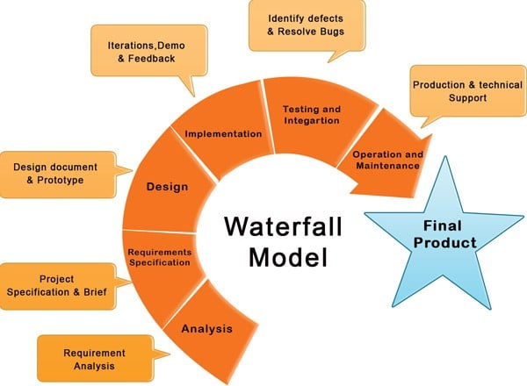

## Tools and Technologies

Several tools and technologies were used in the entire SDLC as shown in figure 8. They are:

* **Windows** and **Ubuntu** as working platforms,
* **MS Word** and **Adobe reader** for ‘Feasibility Study’ and ‘Requirement Analysis and Specification’ phase,
* **Figma, Adobe Photoshop, Adobe Illustrator** and **GIMP** for ‘Design’ phase,
* **Python** with **Tkinter-library** and **Visual Studio Code** for coding in ‘Development’ phase,
* **Sqlite3** for database in ‘Development’ phase,
* **Lucidchart** for conceptual diagram,
* **Git** and **Github** for version control,
* **Discord** for feedbacks and discussion,
* **Google search engine** for research,
* **MS Excel** for project planning.

### Figure 8

Tools and Technology used in project

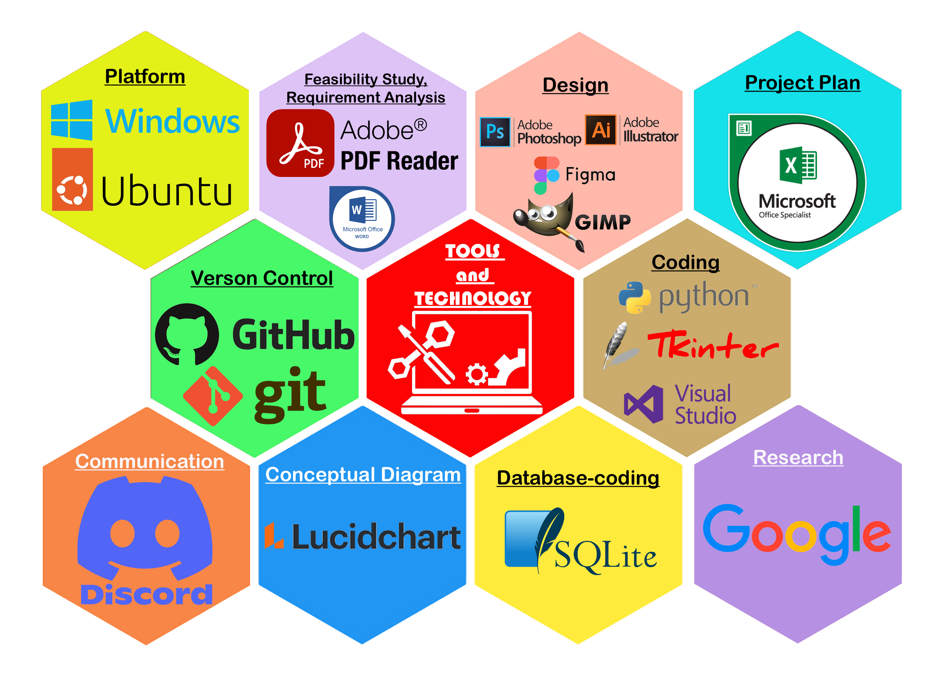

## Conceptual Diagram

Entity-Relationship Diagram explains the relationship between entities in a system diagrammatically. Figure 9 demonstrates ER diagram between entities in this project. Manager manages staff, staff issues bill for order of products of the customers.

### Figure 9

ER Diagram of POS

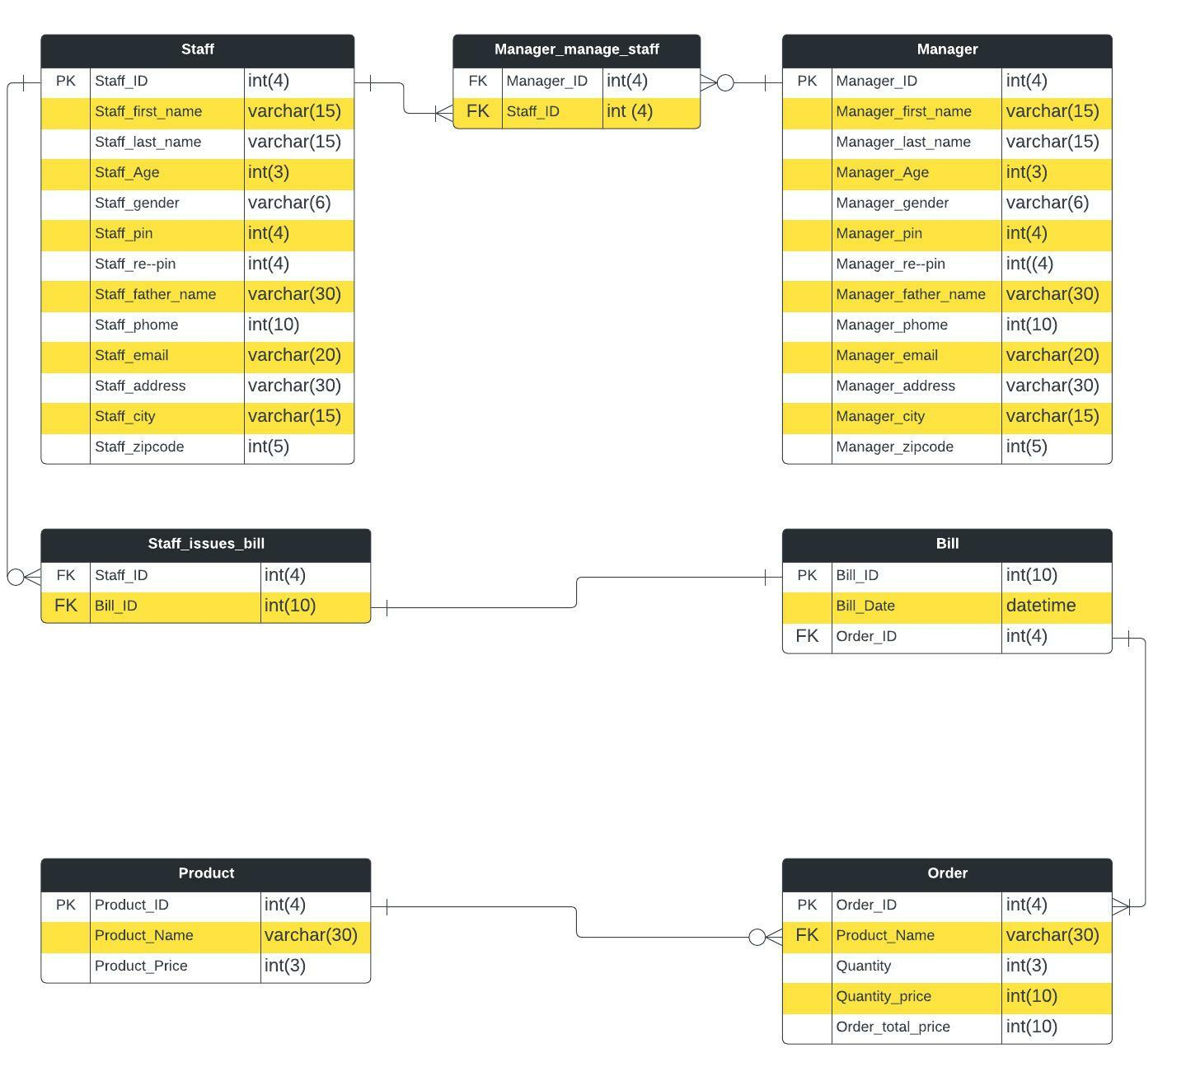

# System Architecture

This system is based on two-tier-architecture which separates its two components namely server and client into two different locations, in which client runs the presentation layer or user interface and server stores the data layer or data structure. It is also referred as ‘Client-Server Application’.

It is used because of its simplicity. In this software, manager enters data to be stored on database in server system. The client system can retrieve any data necessary from server to login or to take orders, can modify data like changing staff credentials, editing order or deleting data if necessary. These requests of client system are updated in server’s database, which can be again accessed through client system (PerfMatrix, 2019). Figure 10 presents a two-tier architecture.

### Figure 10

Two-tier architecture (Baabtra, n.d.).

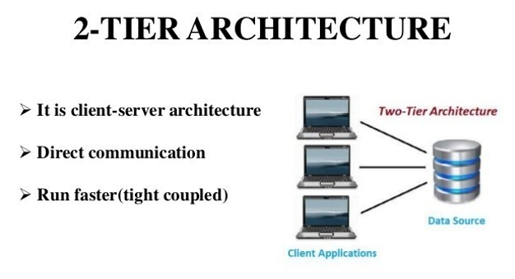

# Project Plan

A progress chart is vital in software engineering to track time, effort, and progress of the software development. The developing team recorded its progress plan using Gannt Chart for all phases of modern waterfall SDLC as informed in figure 11.

### Figure 11

Gannt Chart for work progress

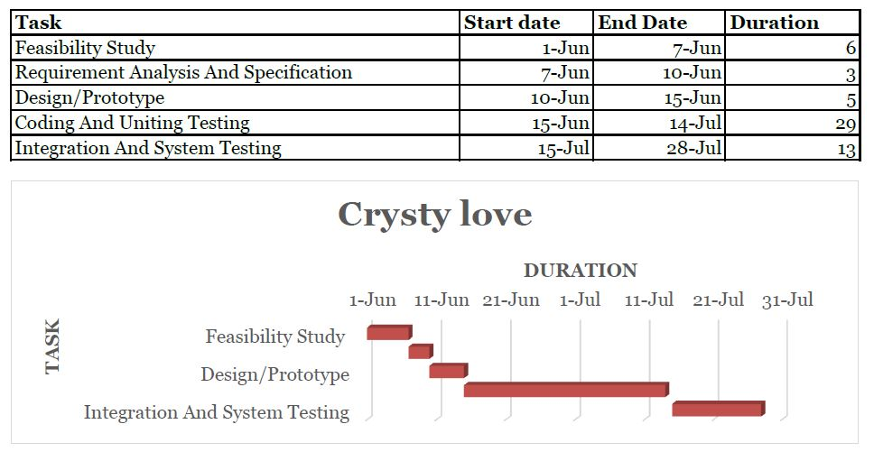

# Prototypes

Prototypes are essential to pave a distinctive path to build a GUI as per SRS document. Several prototypes were built before transforming them into source code. Several throw-away prototypes paved way for subsequent designs. This system is mirrored from the approved prototypes. Designs of this project are shown in figures 12-20.

### Figure 12

Initial Throw-away prototype

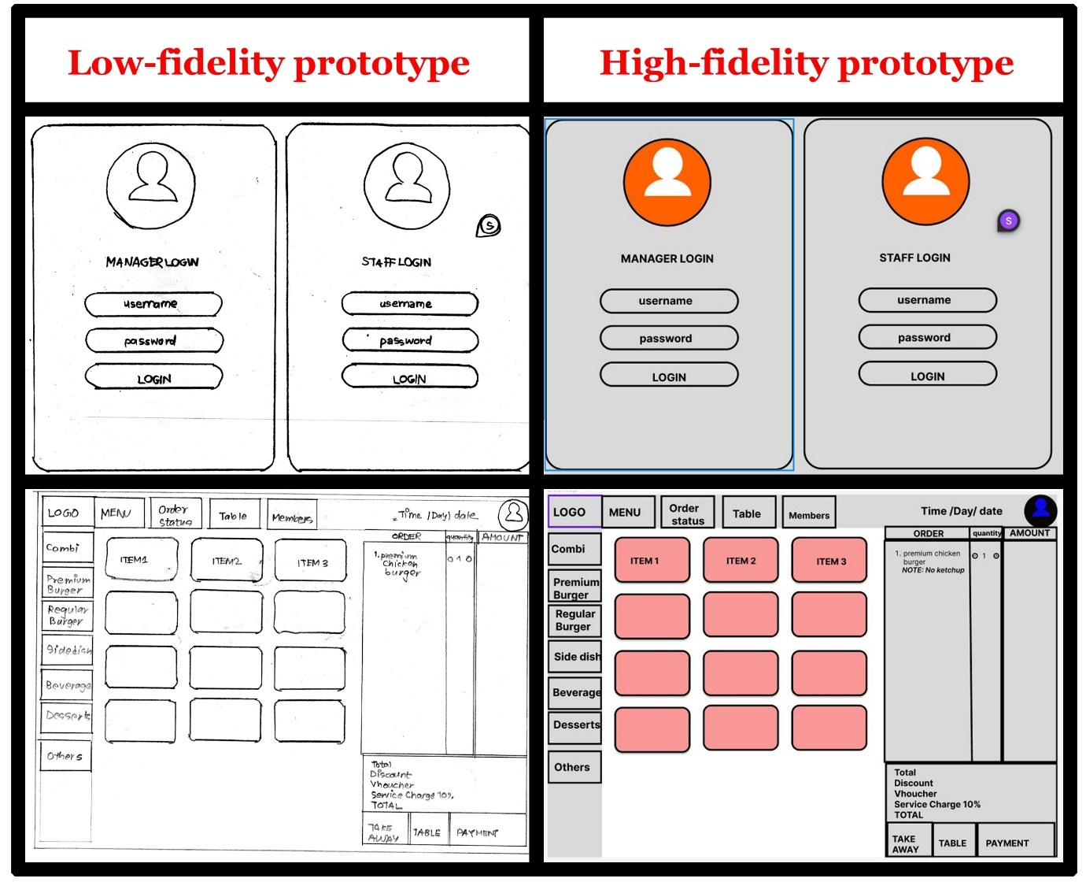

### Figure 13

Manager Login

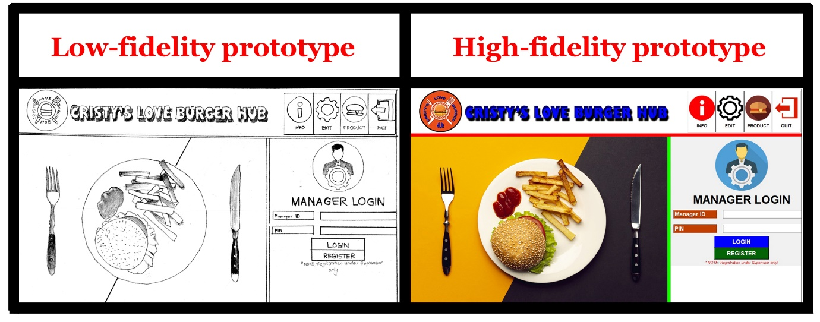

### Figure 14

Staff Login

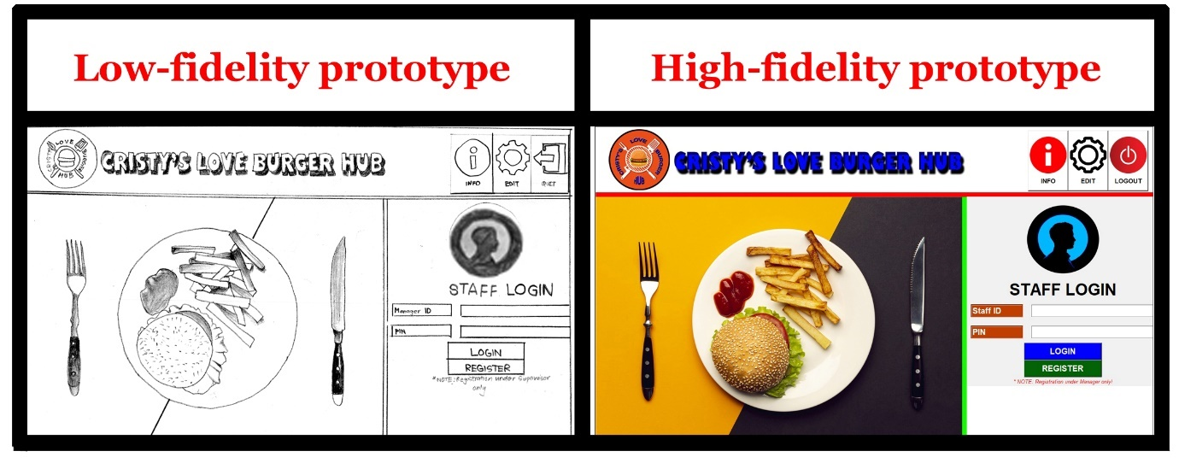

### Figure 15

Product CRUD

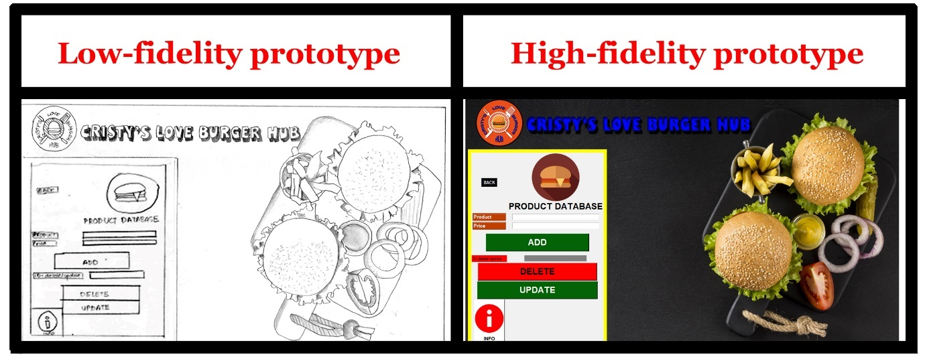

### Figure 16

Manager Registration

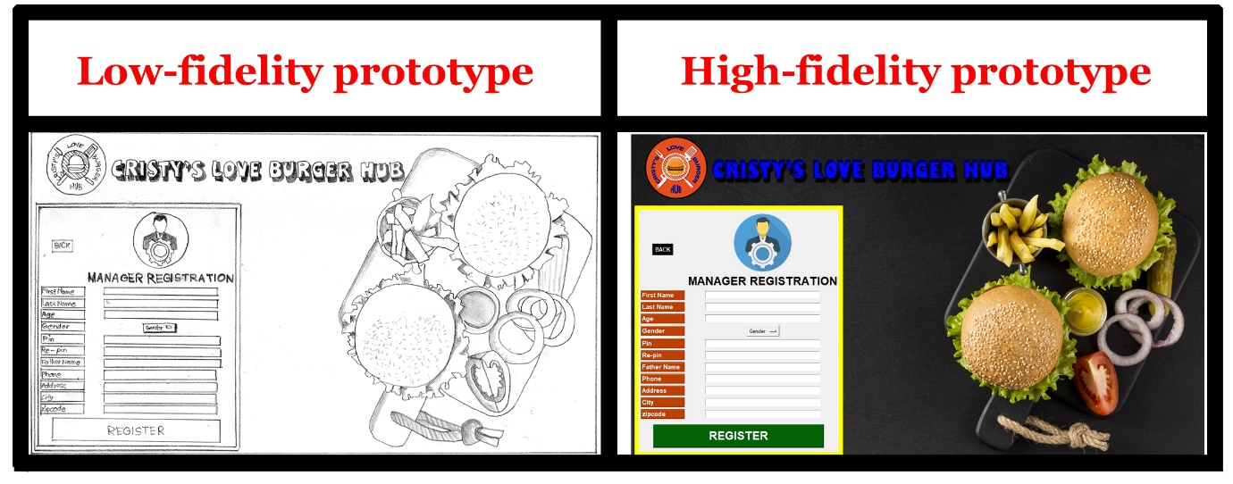

### Figure 17

Staff Registration

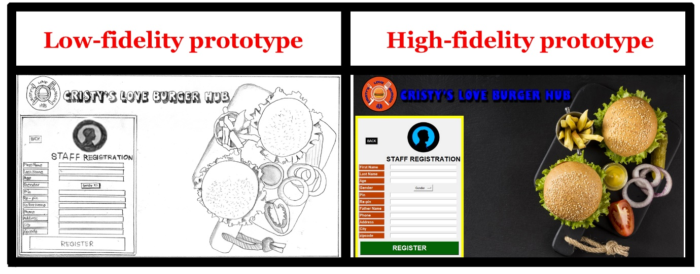

### Figure 18

Edit Manager Data

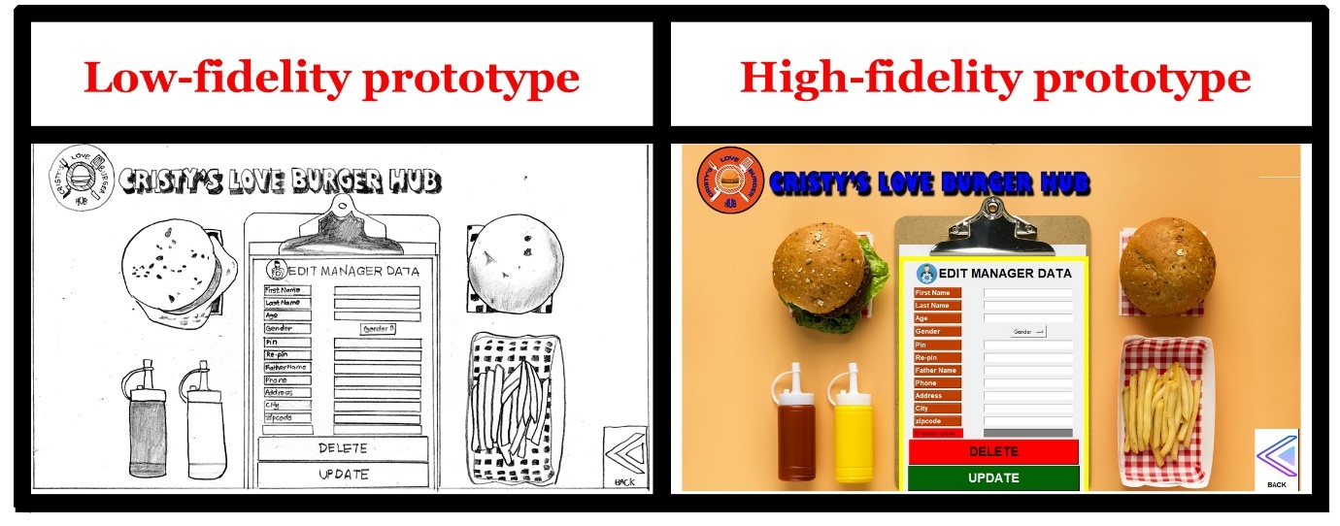

### Figure 19

Edit Staff Data

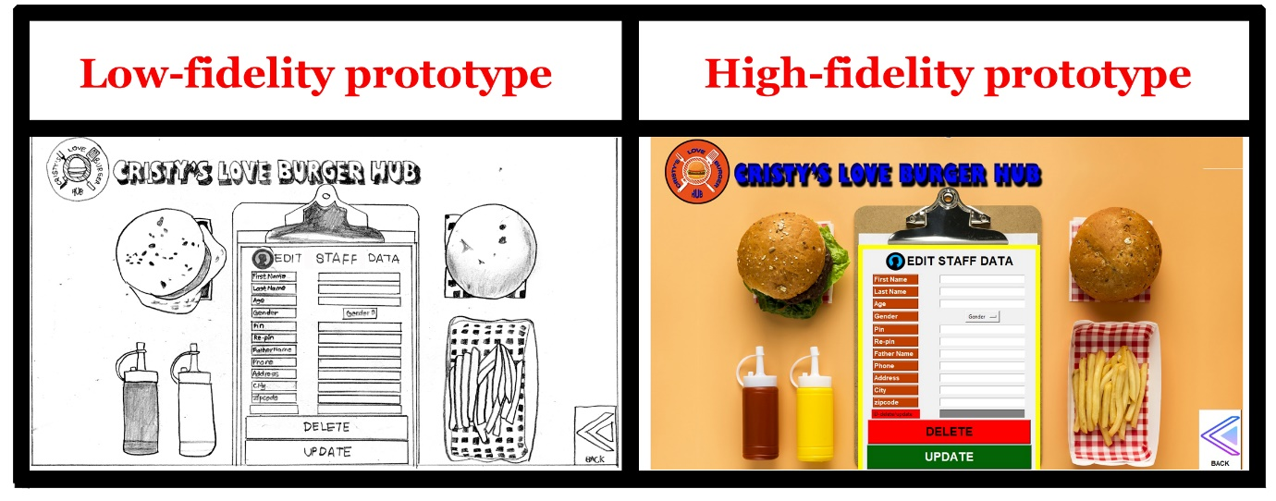

### Figure 20

POS GUI

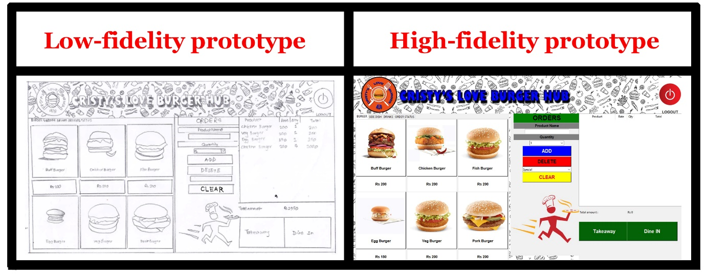

# Developed System

A working software was coded using Python with Tkinter library and Sqlite3 in a systematic and logical manner. The team members divided the workload according to their interest and forte. The team’s understanding of Python programming language with Tkinter GUI tools and Sqlite3 database were applied in coding to develop a fully functional application. The software can be divided into following parts for easy understanding.

## Login UI

Login UI allows a platform to securely login to the employee’s account through valid data entry. “REGISTER’ button checks staff’s authorization to register new employees and forwards to ‘REGISTER’ page after successful verification. Only supervisor can add new mangers while only managers can add new staffs. ‘INFO’ accesses database to view employee ID. ‘EDIT’ button has two functions. Firstly, it authenticates credentials of the employee to update their own data. Secondly, it allows superiors to change their subaltern’s data in instances they forget their pin or delete subordinate’s account if they resign. ‘*MANAGER LOGIN’* page has ‘QUIT’ button to exit the program and ‘PRODUCT’ button for CRUD functions of restaurant products for supervisor and managers. Proper message-box pops when commands are executed. ‘*STAFF LOGIN’* page contains ‘LOGOUT’ button for logged manager to sign-out. ‘STAFF LOGIN’ page can only be accessed after manager signs in to his/her account in ‘MANAGER LOGIN’ page. It is manager’s dashboard. Login pages are shown in figure 21 and 22 with code’s snippet in figure 23.

### Figure 21

Manager Login

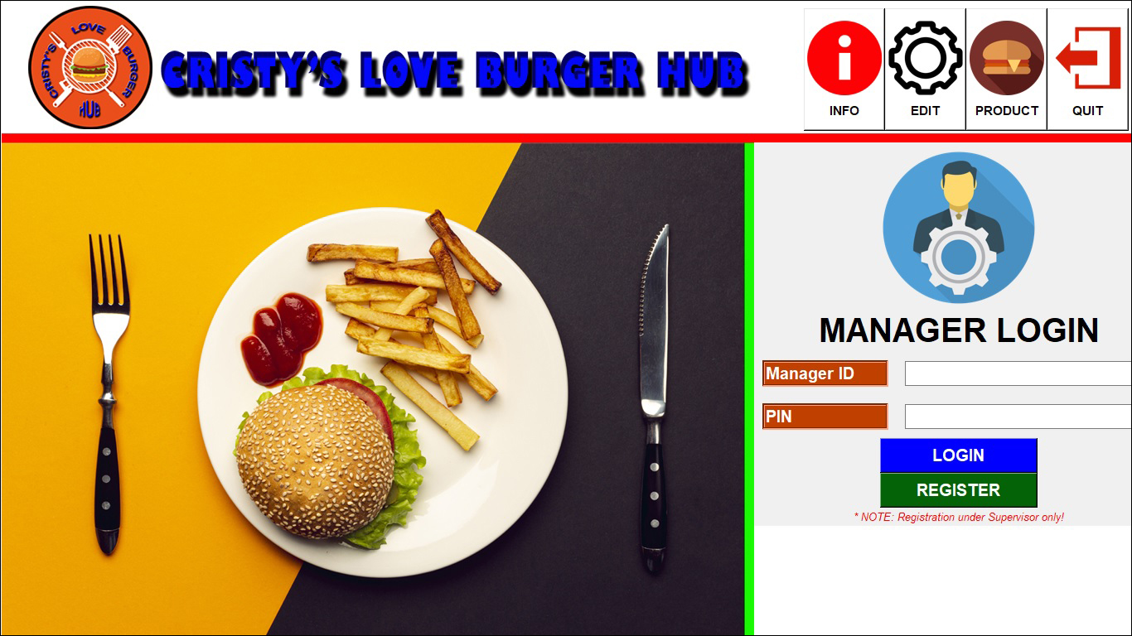

### Figure 22

Staff Login

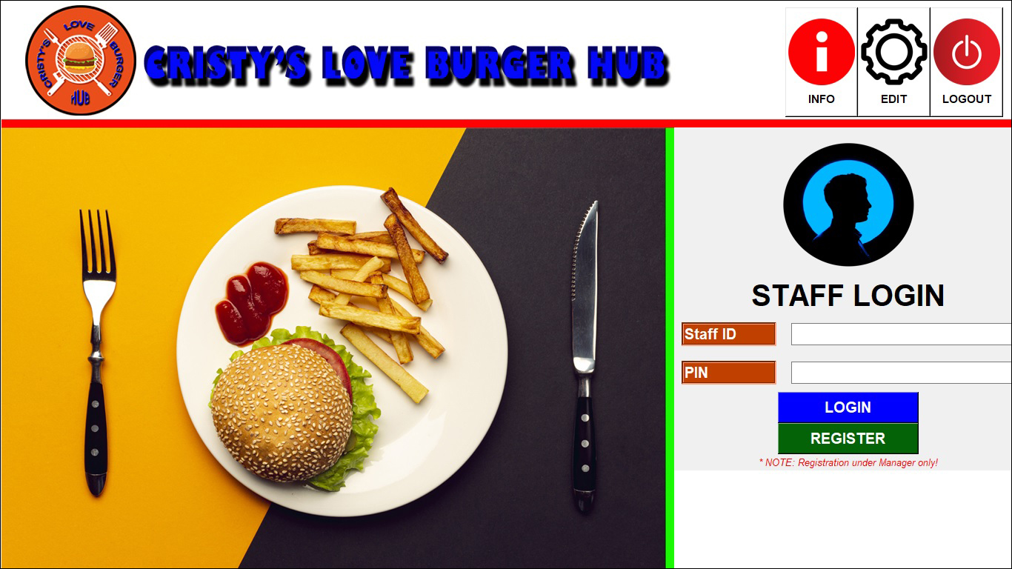

### Figure 23

Login code

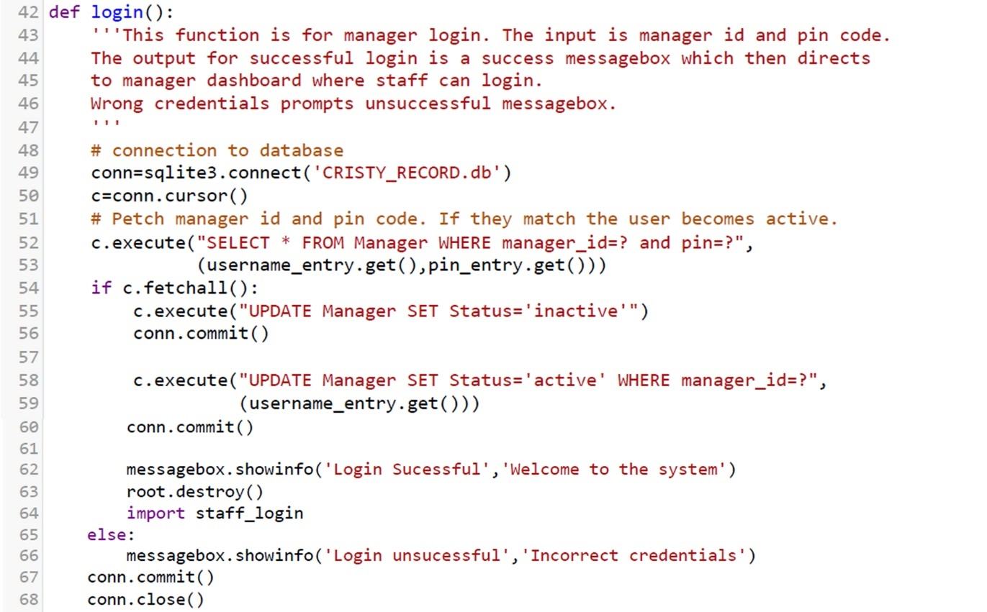

## Registration UI

Registration UI facilitates a platform to register new employees to the database by superiors. All the details are mandatory to be registered in the database. A successful entry results in a ‘success’ message-box while invalid entry prompts ‘failure’ message. ‘BACK’ button enables user to return backward to the previous page. ‘MANAGER REGISTRATION’ is accessed from ‘MANAGER LOGIN’ page while ‘STAFF REGISTRATION’ opens from ‘STAFF LOGIN’ page. Figures 24 and 25 display Registration pages with code’s snippet in figure 26.

### Figure 24

Manager Registration

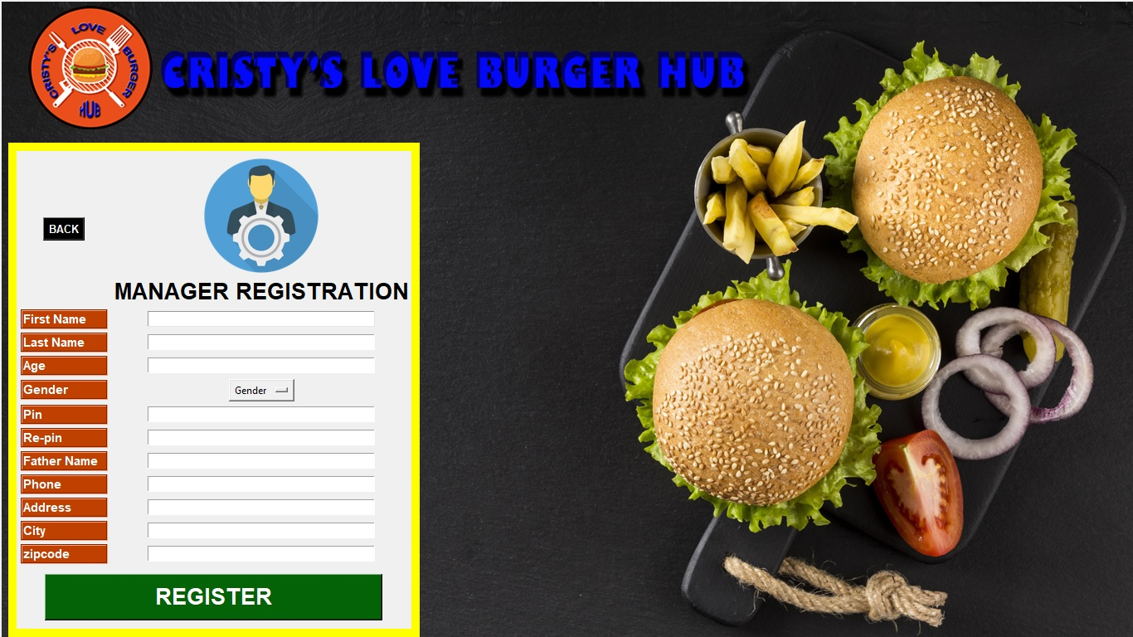

### Figure 25

Staff Registration

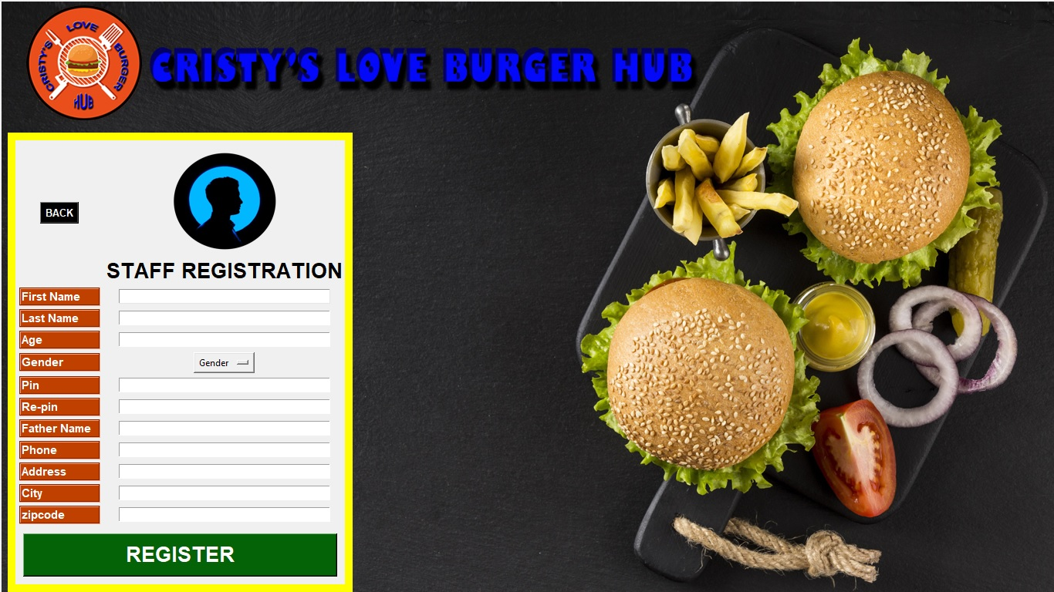

### Figure 26

Registration code

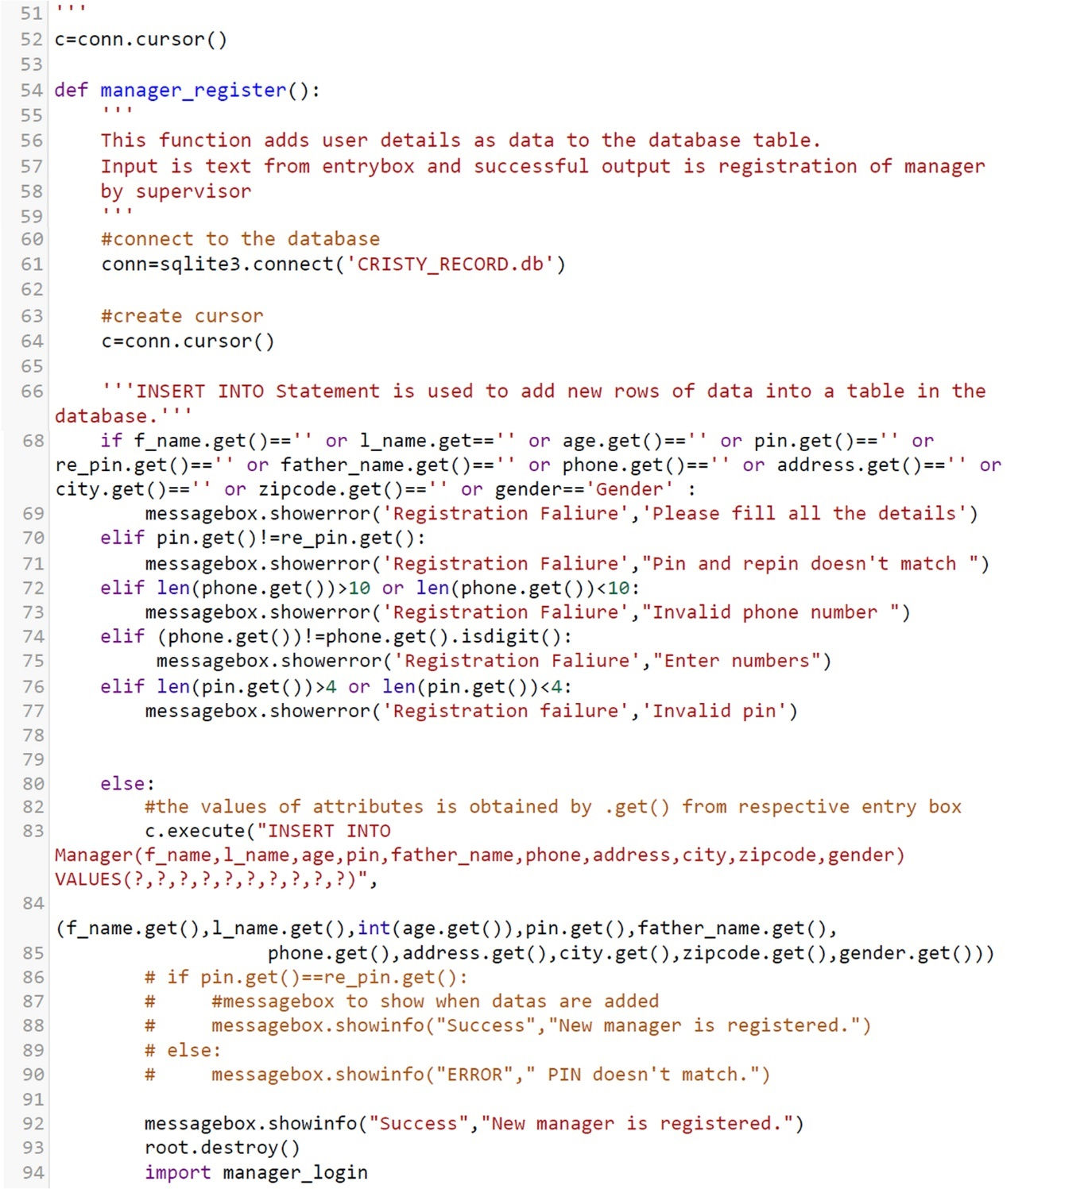

## Product Details UI

It is product’s CRUD page. It is accessible only to supervisor and managers from ‘MANAGER LOGIN’ page. Food items can be added, edited, or deleted in this interface. All fields are mandatory. Proper message-box prompts after each command. ‘BACK’ returns to previous page. Figures 27 and 28 represent its GUI and its code snippet respectively.

### Figure 27

Product Details

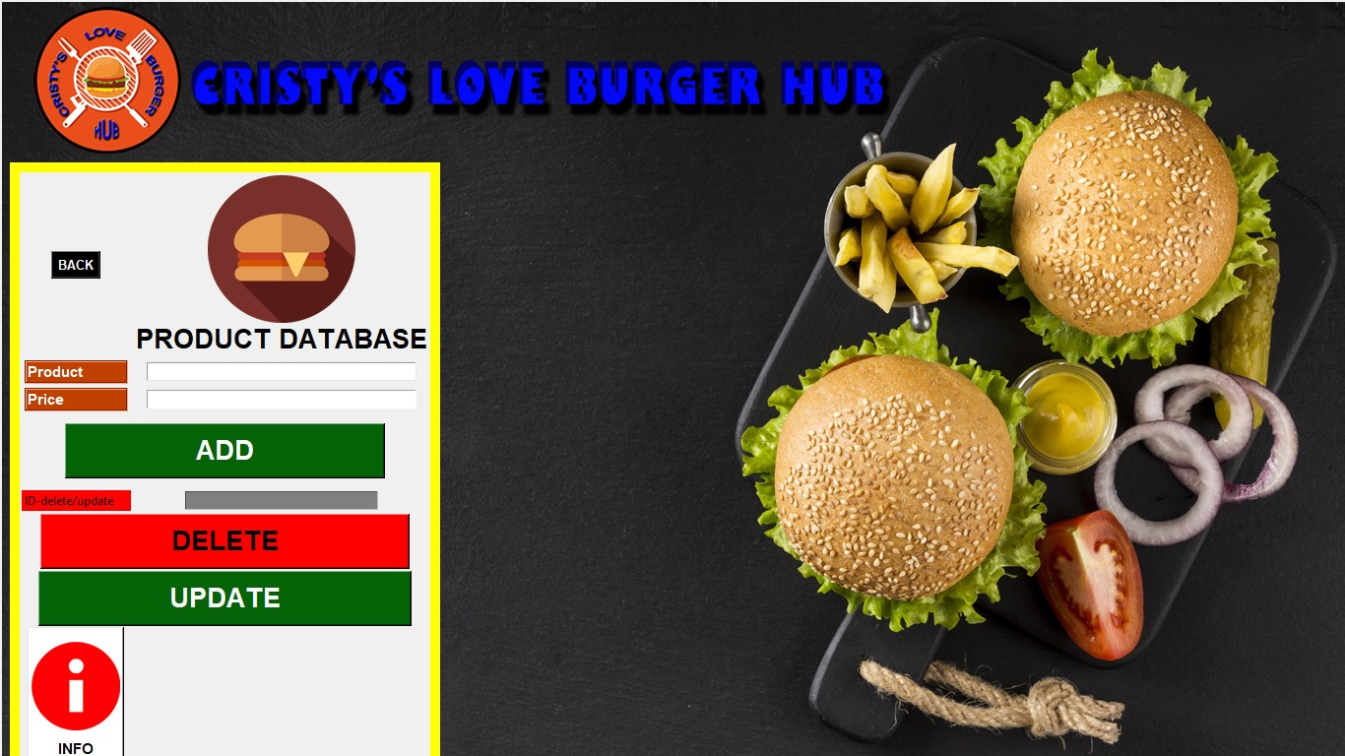

### Figure 28

Product Details’ code

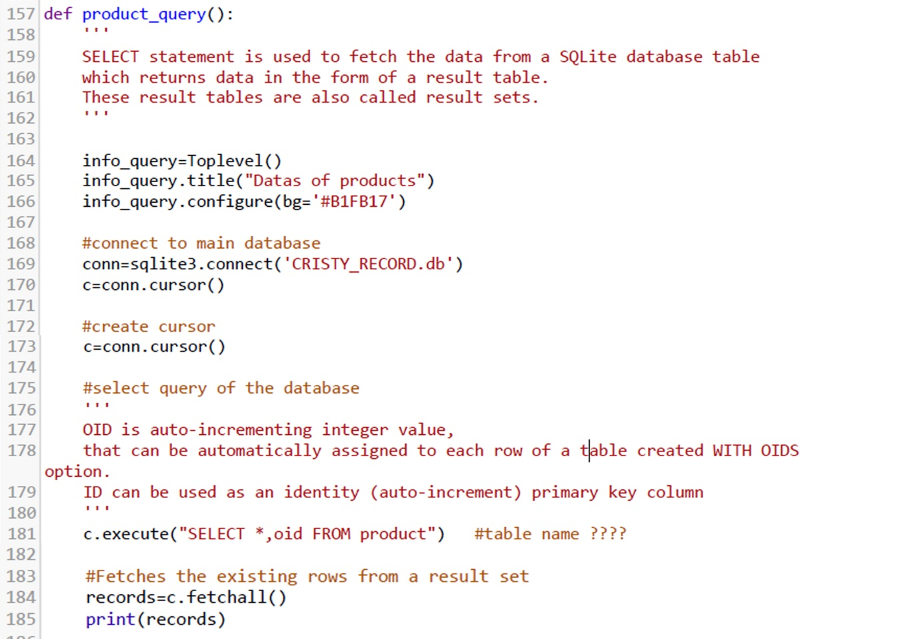

## Update/Delete UI

Employee can access this page to update their respective account after successful login. All fields are mandatory and must be valid. In case of resignation of the employee, superior staff can access this page to permanently delete the quitted employee’s records. Managers and staffs have their respective ‘EDIT’ page as shown in figures 29 and 30, with their code snippet in figure 31.

### Figure 29

Edit Manager Data

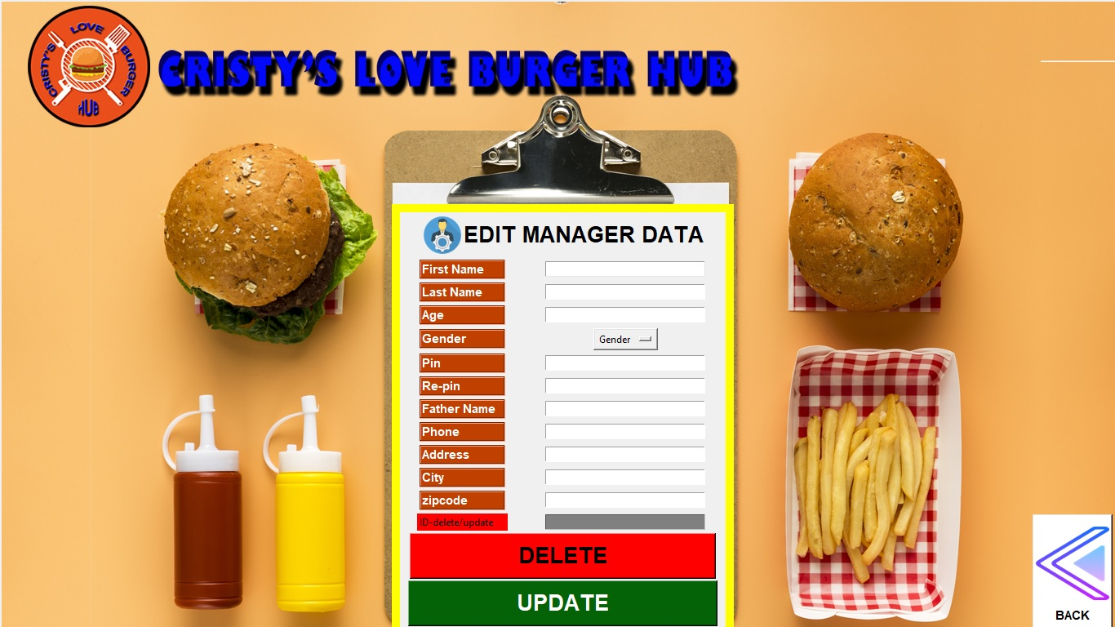

### Figure 30

Edit Staff Data

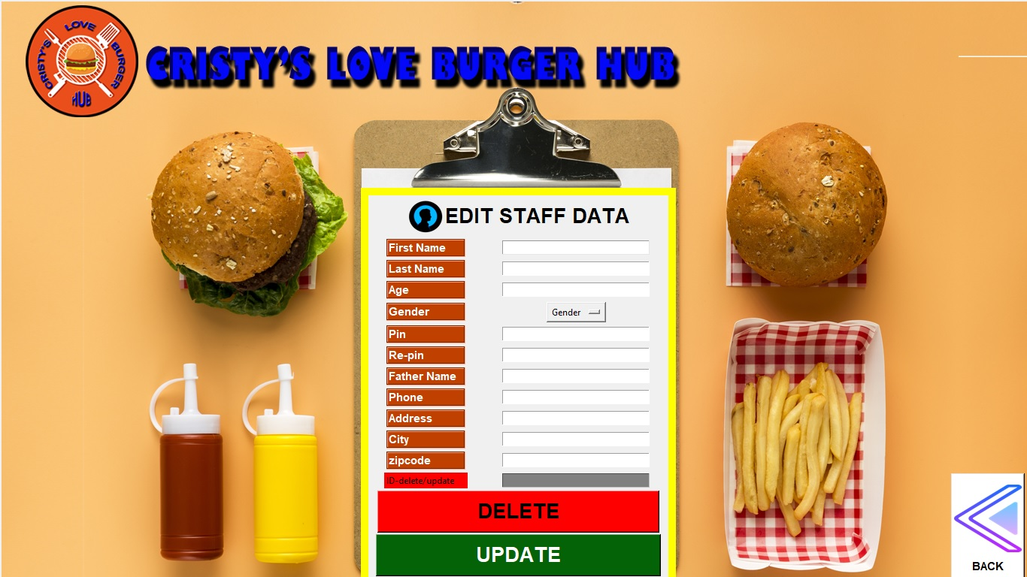

### Figure 31

Code of Edit Data

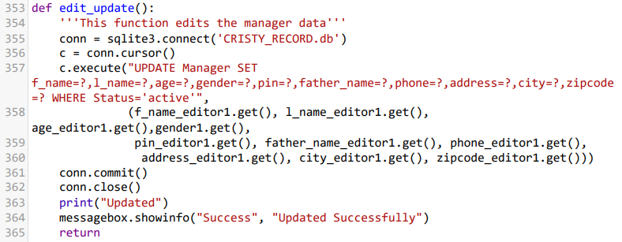

## POS UI

This page is the main order page of the system. Cashier takes order from the customers and complete transactions in this page. It consists of available restaurant products with price details in their respective category. The staff can add, read, edit, and delete customer’s order as per need. Accounting is automatic and accurate. Customers can choose to ‘EAT IN’ or ‘TAKE AWAY’. Staff can check the status of the order in ‘ORDER STATUS’ tab and update it as ‘complete’ when foods are delivered to the patrons. Staff can logout from their account after their shift is complete through ‘LOGOUT’.

Figures 32 and 33 shows the POS UI and its code’s snippet respectively.

### Figure 32

POS UI

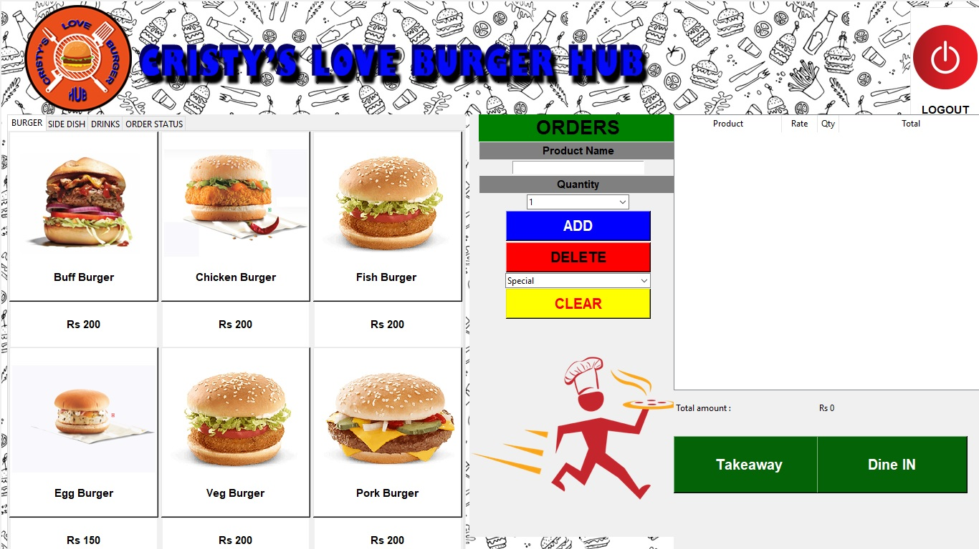

### Figure 33

Code of POS UI

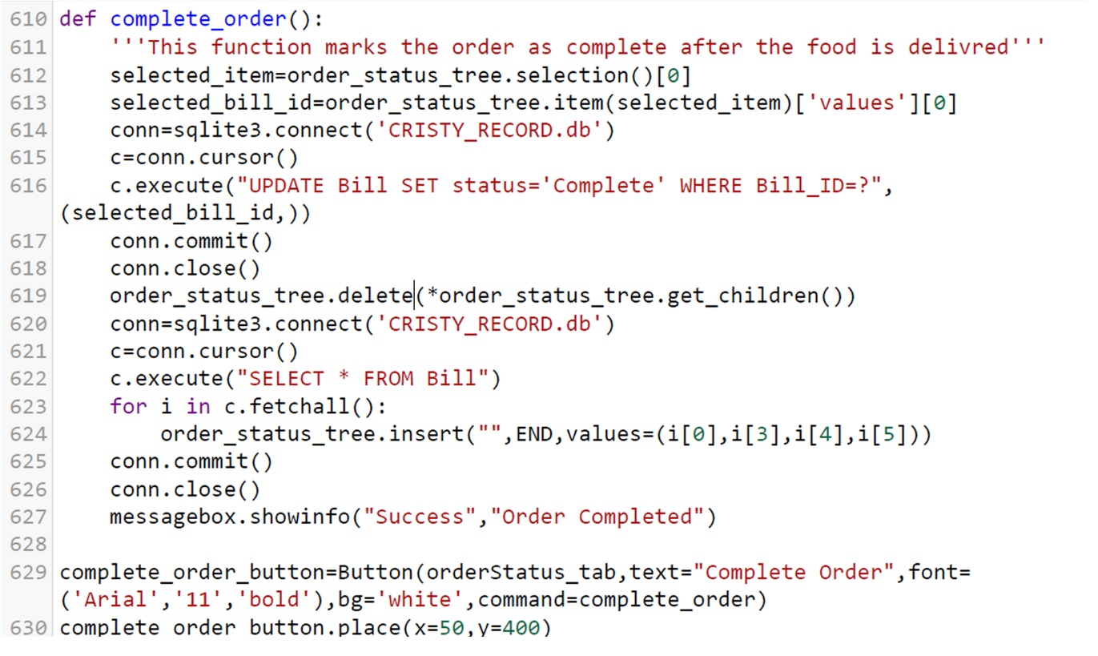

# System Testing

Black box testing was performed for system testing after the completion of coding to check its functionality as per SRS manual as shown in figures 34 to 42. Outputs were recorded to the test cases. Errors were corrected until all test cases were satisfied.

### Figure 34

Manager Registration test

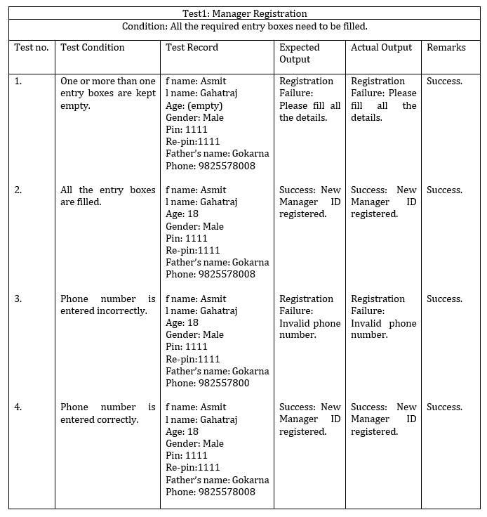

### Figure 35

Manager Login test

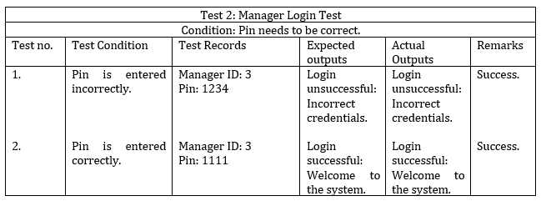

### Figure 36

Staff Login test

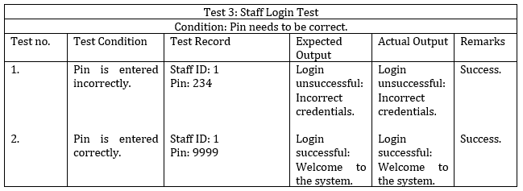

### Figure 37

Staff Registration test

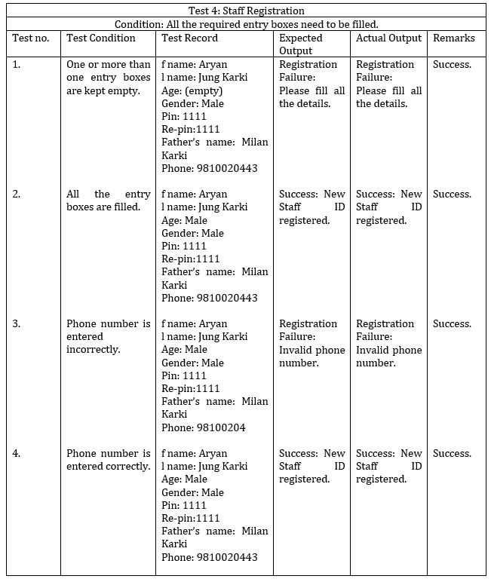

### Figure 38

Manager CRUD test

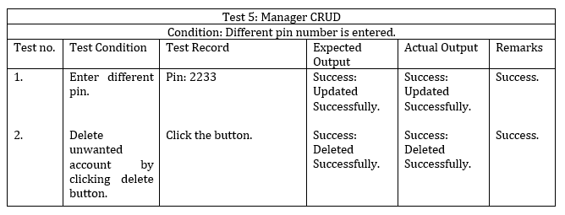

### Figure 39

Staff CRUD test

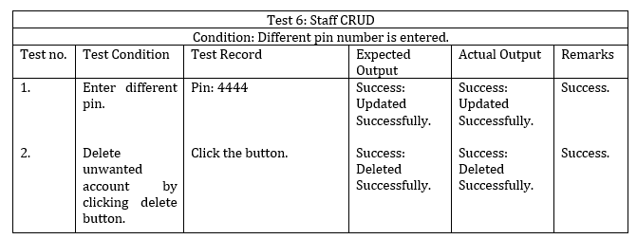

### Figure 40

Logout test

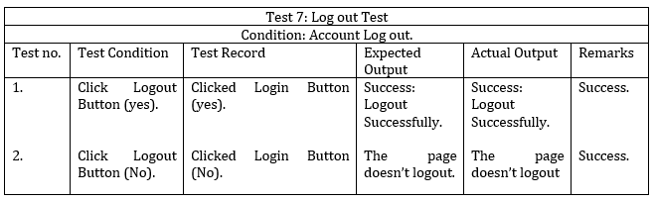

### Figure 41

Order test

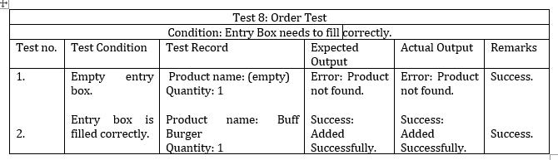

### Figure 42

Order status test

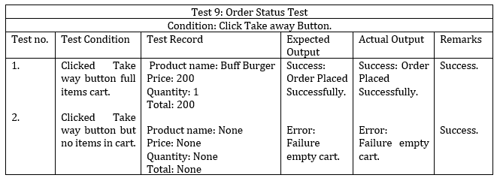

# Version Control

* **Github:** <https://github.com/softwarica-github/st4008cem-cw-32a-cristy-s-love-burger-hub-3.git> as shown in figure 43.
* **Youtube:** https://youtu.be/ZisTQN81Svg

### Figure 43

Version control of the project

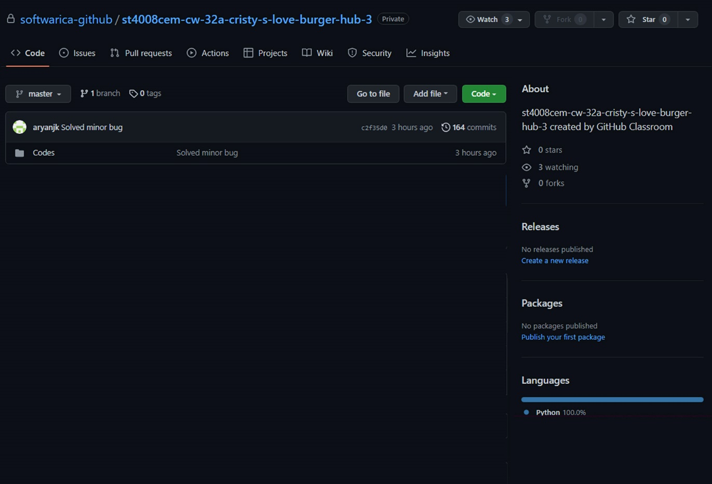

# Conclusion

The team engineered the final working product as per the requirement stated in user manual by integrating all the concepts learned in classroom from modules like Mathematics, Programming and Algorithm, and Software Design. Available technologies were used to their fullest.

This project solves the problem of traditional pen-paper order-taking in restaurants, focuses mainly on double-factor secure login and digital calculation of transactions. Both the functional and non-functional requirements as stated in the SRS are fully satisfied. System testing has shown positive results. All the bugs noticed during the implementation phase are already solved by the team with proper interaction and sharing of knowledge. The GUIs can be systematically accessed through correct credentials and user can be worry-free about their privacy. Through good teamwork the GUI is built to be attractive, presentable, simple, user-friendly, and self-describable.

The team has gained precious experience of developing a software from scratch for the first time, making us realize our severe lack of expertise in the IT field. Nevertheless, each effort in future will build us to be better in our careers by expanding our experiences. The desire to learn and grow through new challenges is our driving point. Friendly interaction between teammates and instructor, reminds us that knowledge expand by sharing. The team pledges to be better in IT field through open-minded learning, taking new challenges to create software as per need incorporating logics and following the IT ethics.

# References

Baabtra. (n.d.). *2 tier and 3 tier architecture*. Slideshare. Retrieved June 8, 2022, from <https://www.slideshare.net/BaabtraMentoringPartner/2-tier-and-3-tier-architecture>

Brophy, M. (2021, August 5). *What Is a Point-of-Sale (POS) System & How Does it Work?* Fit Small Business. Retrieved June 5, 2022, from <https://fitsmallbusiness.com/what-is-a-pos-system/>

Chalberg, M. (2018, May 3). *12 Essential POS System Features: What Every POS Must Have*. KORONA POS. Retrieved June 7, 2022, from <https://koronapos.com/blog/pos-system-features/>

GeeksforGeeks. (2021, September 29). *Software Engineering | Iterative Waterfall Model*. Retrieved June 8, 2022, from https://www.geeksforgeeks.org/software-engineering-iterative-waterfall-model/

Harper, A. (2021, February 5). *Retail Order Management System In General*. JEVERA. Retrieved June 5, 2022, from <https://www.jevera.software/post/retail-order-management-system-in-general>

Miller, F. (2022, April 18). *Five Examples of POS Systems Used in Businesses*. Productivity Land. Retrieved June 5, 2022, from <https://productivityland.com/five-examples-of-pos-systems-used-in-businesses/>

Morisio, M. (2013, January 1). *Requirement engineering Exercise – the POS System solution*. Retrieved 7 June, 2022, from <https://softeng.polito.it/tongji/SE/ex/The-POS-system.pdf>.

Nitika, N. (2018, February 27). *WHAT IS THE ROLE OF WATERFALL MODEL IN SDLC*. Loginworks. Retrieved June 8, 2022, from <https://www.loginworks.com/blogs/role-waterfall-model-sdlc/>

Nicasio, F. (2018, April 6). *22 POS Features to Look for in a Retail Management System*. Vend Retail Blog. Retrieved June 7, 2022, from <https://www.vendhq.com/blog/pos-features-for-retail-management-systems/>

PerfMatrix, P. (2019, February 1). *Software Architecture and its types*. PerfMatrix. Retrieved June 8, 2022, from <https://www.perfmatrix.com/software-architecture-and-its-types/>

Pos, A. (2022, January 14). *6 Key Features of a POS System*. Alice POS. Retrieved June 7, 2022, from <https://alicepos.com/6-key-features-of-a-pos-system/>

Pos, A. (2022, January 14). *27 Advantages of a POS System*. Alice POS. Retrieved June 6, 2022, from <https://alicepos.com/27-advantages-of-a-pos-system/#:%7E:text=In%20general%2C%20a%20POS%20system,store%20for%20their%20next%20purchase>

Prajapati, V. (2020, March 3). *What are the Objectives of a Point of Sale System?* TechPrevue. Retrieved June 5, 2022, from <https://www.techprevue.com/objectives-point-sale-system/>

Restora. (2022, January 5). *Restora POS: Next-Generation Restaurant POS System*. Restorapos. Retrieved June 5, 2022, from <https://restorapos.com/>

Talech, A.-T. (2020, July 15). *Implementing Point of Sale Systems: Scope and Limitations*. Talech Thrive. Retrieved June 7, 2022, from <https://www.talech.com/blog/2020/07/15/resources-implementing-point-of-sale-systems-scope-and-limitations/>